4th Grade Writing
Standard | 3.0 Items
4.20 (B)  use the complete subject and the complete predicate in a sentence. | 4.20B/3.0  Option 1  - Construct a sentence using a complete subject and complete predicate.  - Underline the complete subject.  - Circle the complete predicate.  - Construye una oración completa usando un sujeto y un predicado.  - Subrayo el sujeto completo.  - Circula el predicado completo.  4.20B/3.0  Option 2  Construct a sentence using your choice of complete subjects and complete predicates from the selections below:  went to the Houston Zoo  the children in Mrs. Jones’ third grade class  the principal at Humble Elementary  attended the fifth grade concert  the silly second grade teacher  walked to the cafeteria to eat lunch  Selecciona un sujeto y un predicado de la lista de abajo y construya una oración completa.  fue al Zoologico de Houston  los estudiantes en tercer grado de la clase de la Sra. Jones  la directora de la escuela Humble Elementary  asistí al concierto de quinto grado
 | 2.0 Items
4.20B/2.0
Option 1

What is a subject?
______________________________________________
What is a predicate?
______________________________________________

Que es un sujeto?
______________________________________________

Que es un predicado?
______________________________________________

4.20B/2.0
Option 2

Use a complete subject to complete the sentence below:

__________________attended the fifth grade concert.

Use a complete predicate to complete the sentence
below:

The silly second grade teacher _____________________.

Usa un sujeto completo para completar la oración de abajo:

__________________ asistió el concierto de quinto grado.

Usa un predicado completo para completar la oración de abajo:

La graciosa maestra de segundo grado_________________.

Standard | 3.0 Items
Writing Process  4.15 (B) develop drafts by categorizing ideas and organizing them into paragraphs  4.15 (C) revise drafts for coherence, organization, use of simple and compound sentences, and audience;  4.15(D): Edit drafts for grammar, mechanics, spelling  4.17(A): Write about important personal experiences | 4.15B;4.15C;4.15D;4.17A/3.0  Option 1  Write about a personal experience that you have had.  I can:  - Plan a beginning, middle and end.  - Generate a first draft.  - Read draft for coherence and make revisions (dialogue, word choice, and use of sensory and figurative language).  - Read draft for organization and make revisions (lead, conclusion, transition words).  - Read draft and make revisions, using both simple and compound sentences.  - Read draft and make revisions based on your intended audience.  - Read draft and edit for mechanics.  - Read draft and edit for spelling.  - Read draft and edit for grammar.  Translate: Write about a personal experience that you have had.  Yo puedo:  - Planificar el principio, medio y final.  - Escribir/producir el primer borrador  - Leer el borrador para ver si tiene sentido y para revisar (diálogo, uso de lenguaje, sensoriales y lenguaje figurado).  - Leer el borrador para ver si está organizado y para revisar (introducción, conclusión, y palabras transiciones).  - Leer ei borrador y hacer revisiones basando en la audiencia  - Leer el borrador y editar para estructura  - Leer el borrador y editar para ortografía  - Leer el borrador y editar para gramáticas  4.15B;4.15C;4.15D;4.17A/3.0  Option 2  Think of an enjoyable experience that you have had at school that would be hard to forget. Think about what makes it so hard to forget. Plan and write a multi-paragraph narrative to tell what happened.  I can:  - Plan a beginning, middle and end.  - Generate a first draft.  - Read draft for coherence and make revisions (dialogue, word choice, and use of sensory and figurative language).  - Read draft for organization and make revisions (lead, conclusion, transition words).  - Read draft and make revisions, using both simple and compound sentences.  - Read draft and make revisions based on your intended audience.  - Read draft and edit for mechanics.  - Read draft and edit for spelling.  - Read draft and edit for grammar.  Piensa en una experiencia agradable que has tenido en la escuela que es inolvidable. Piensa en porque esta experiencia es inolvidable. Planea y escribe un narrativo personal de múltiple párrafos y describe lo que pasó.  Yo puedo:  - Planificar el principio, medio y final.  - Escribir/producir el primer borrador  - Leer el borrador para ver si tiene sentido y para revisar (diálogo, uso de lenguaje, sensoriales y lenguaje figurado).  - Leer el borrador para ver si está organizado y para revisar (introducción, conclusión, y palabras transiciones).  - Leer ei borrador y hacer revisiones basando en la audiencia  - Leer el borrador y editar para estructura  - Leer el borrador y editar para ortografía  - Leer el borrador y editar para gramáticas
Standard | 2.0 Items
4.15 (C) revise drafts for coherence, organization, use of simple and compound sentences, and audience; | 4.15C/2.0  - Define coherence.  - Why does a writer consider his/her audience before composing?  - Circle the simple sentence in the next set of sentences:  - She swam.  - He rode his horse to the park.  - Create a simple sentence.  - Circle the compound sentence in the next set of sentences:  - Akayla ran to the bus stop, and Sasha walked to school.  - Ramiro rode his horse to school.  - Create a compound sentence.  - Definir la palabra “coherente”  - Porque un autor considera la audiencia antes de escribir?  - Identificar una oración simple.  - Identificar un oración compuesta.  - Crear un oración compuesta.

Standard | 2.0 Items
4.15(B) develop drafts by categorizing ideas and organizing them into paragraphs | 4.15B/2.0  Option 1  Write a lead for this personal narrative.  First, I walked out on the diving board. I was as nervous as a kid on the first day of school! The board wobbled, and I almost lost my balance. I was so high up!  Summoning up my courage, I carefully walked to the end of the diving board. I pictured myself flying like an eagle off the board and into the water. 1, 2. 3, and I dove!  I’ll never forget that amazing day when I dove off the high dive. I learned that it is important to be courageous.  Escribe un “gancho” para este narrativo personal.  Primero, yo camine al brincolin del alberca. Estaba bien nervioso así como un niño en su primer dia de la escuela! El brincolin se tambaleó, y casi perdí mi balanza. El brincolin Estaba tan alto!  Tratando de ser valiente, cuidadosamente camine al extremo del brincolin. Me imagine que brincaba y estaba volando como una águila. 1, 2, 3 y me clave al agua!  Nunca me olvidare de este dia tan asombroso cuando me tire del brincolin tan alto. Aprendí que es importante ser valiente.  4.15B/2.0  Option 2  Write a conclusion for this personal narrative.  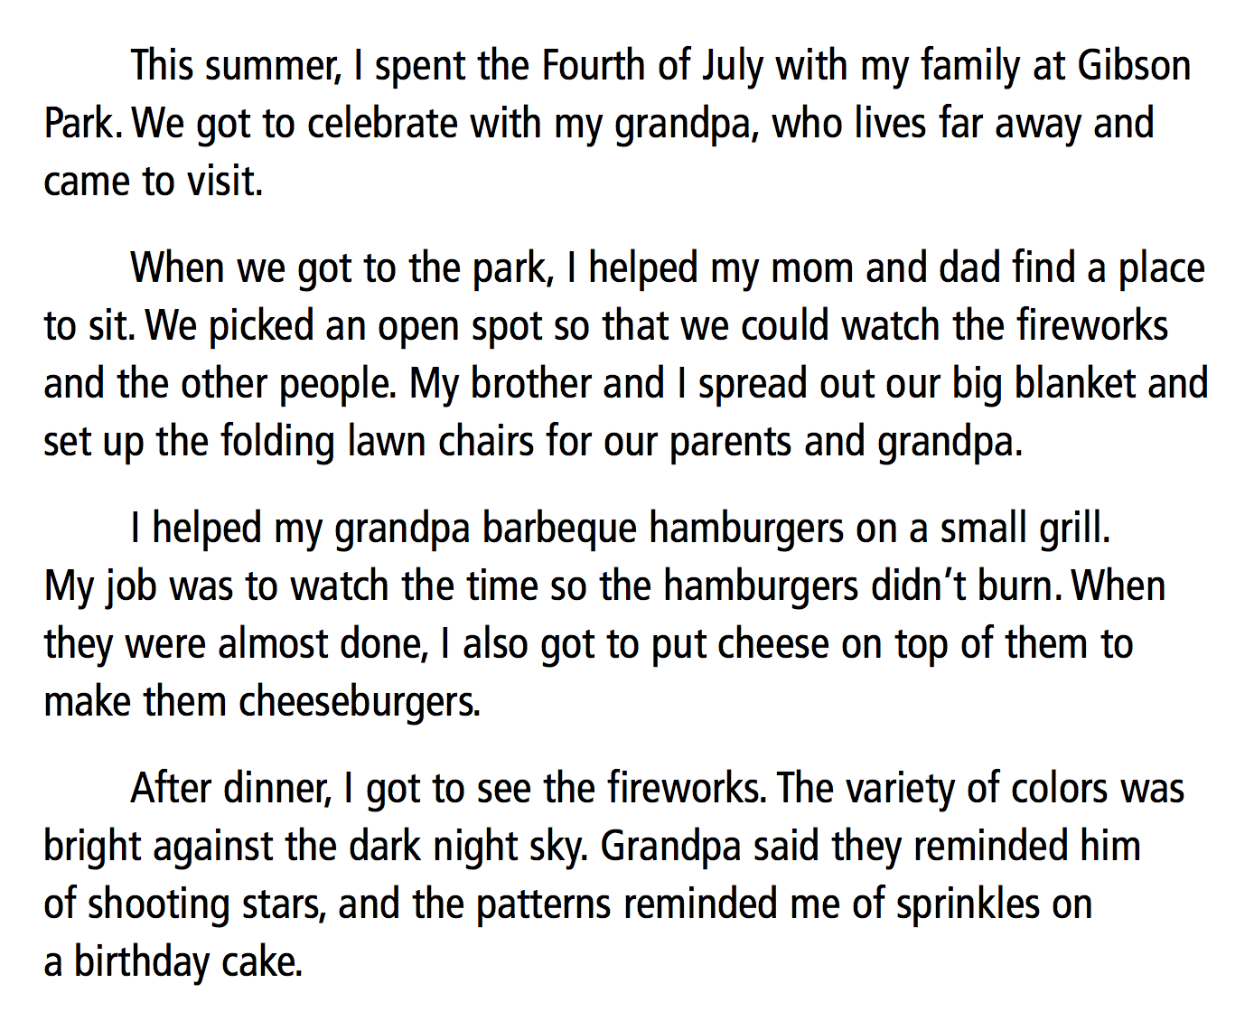  2.0 #8 Escribe una conclusión para esta narrativo personal.  Durante el verano, pase el cuarto de julio con mi famila en Gibson Park. Celebramos con mi abuelo que vino de tan lejos para visitar.  Cuando llegamos al parque, le ayude a mi mama y mi papá a buscar un lugar para sentar. Escogimos un lugar abierto para poder ver los fuegos artificiales y la de mas gente. Mi hermano y yo extendimos nuestra colcha grande y colocamos las sillas para nuestros padres y abuelo.  Le ayude a mi abuelo hacer las hamburguesas con una parrilla pequeña. Me correspondía de que no se quemaban las hamburguesas. Cuando casi estaban hechas, les puse queso arriba para hacer “hamburguesas con queso”.  Después de cenar, vi a los fuegos artificiales. La variedad de colores eran tan brillantes contra la oscuridad de la noche. Abuelo dijo que le recordaba de las estrellas fugaces, y los patrones le recordaba de chispas arriba de un pastel de cumpleanos.

Standard | 3.0 Items
4.20A  Use and understand the function of the following parts of speech in the context of reading, writing, and speaking:  (ii) nouns (singular/plural, common/proper) | 4.20Aii/3.0  Option 1  - Write a paragraph that includes the following:  - singular nouns  - plural nouns  - common nouns  - proper nouns  - Underline the singular nouns you used.  - Circle the plural nouns you used.  - Box the proper nouns you used.  - Escribe un párrafo que incluye lo siguiente:  Yo puedo:  - Usar sustantivos propios  - Usar sustantivos plurales  - Usar sustantivos comunes  - Usar sustantivos propios  B. Subraya los sustantivos singulares.  C. Circula los sustantivos plurales.  D. Dibuja un caja alrededor de los sustantivos propios.  4.20Aii/3.0  Option 2  dolphins Fiesta Texas Mr. Jones  Mrs. Jones vacation Mrs. Jones  roller coaster South Padre Island seashells  When they had to decide where to go on their ____, ______ wanted to go to ________, but ______ wanted to to to ______. ________ really wanted to see the _______ and collect _____, but Mr. Jones just wanted to relax by riding the ________.  delfines Fiesta Texas Sr. Jones  Sra. Jones vacacion Sra. Jones  montana rusa Isla de South Padre conchas
 | 2.0 Items
4.20Aii/2.0
Option 1
Underline the proper nouns in the following sentence:

James and Alonzo wanted to go to the Houston Children’s Museum and the zoo.

Underline the common nouns in the following sentence:

Sophia owned a cat named Hortense and a dog named Jasper.

Subraya los sustantivos propios en la oración siguiente:

James y Alonzo querían ir al Museo de los Ninos de Houston y al zoológico.

Subraya los sustantivos comunes en la oración siguiente:

Sophia tiene una gata llamada Hortensia y un perro llamado Jasper.

4.20Aii/2.0
Option 2
Write a sentence that includes at least one singular noun.

Write a sentence that includes at least one plural noun.

Explain the difference between a common and a proper noun.

Escribe una oración que incluye por lo menos un sustantivo singular.

Escribe una oración que incluye por lo menos un sustantivo plural.

Explica la diferencia entre un sustantivo común y un sustantivo plural.

4.20Aii/2.0
Option 3
Which of the following sentences contain both common and proper nouns?

- The dog and the cat lived in the same house.
- Coach Moreno attended the University of Houston.
- Ms. Roberts went to work on a cold, rainy day.
- Dolphins and porpoise live in the ocean.

Cual de las siguientes oraciones contiene ambos sustantivos comunes y propios?

E. El perro y el gato viven en la misma casa.
F. Coach Moreno asistio la Universidad de Houston.
G. Sra. Roberts fue al trabajo en un dia frio y lluvioso.
H. Delfines y marsopas viven en el océano.

4.20Aii/2.0
Option 4
Which of the following sentences contain both singular and plural nouns?
- When Avery visited Old McDonald’s Farm, he rode a pony and fed the chickens.
- When Maria went to Deerbrook Mall, she bought a new bracelet.
- David and Joanna visited the new museum.
- Vacationers love to visit beaches.

Cual de las siguientes oraciones contienen ambos sustantivos singulares y sustantivos plurales?

- Cuando Avery visitó a la Granja de Old McDonald’s, monto a una jaquita y le dio de comer a los pollos.
- Cuando María fue al Mol/centro comercial de Deerbook, compró una pulsera nueva.
- David y Joanna visitaron al nuevo museo.
- Las turistas les encantan visitar a las playas.

Standard | 3.0 Items
4.22 (D) use spelling patterns and rules (and print and electronic resources) to determine and check correct spellings | 4.22D/3.0  Option 1  What change, if any, should be made to the following sentences:  A.  We had to make sure that all the plants were recieving just the right amount of water.  B.  Oliver waged his tail in delight.  4.22D/3.0  Option 2  Identify the sentences with the correctly spelled words  A.  - Bobby rod his bike for the first time without training wheels.  - Bobby rode his bike for the first time without training wheels.  B.  - The groundhog popped his head out of the hole to check the weather.  - The groundhog poped his head out of the hole to check the weather.  4.22D/3.0  Option 3  - Look at the picture below and write the word correctly that describes what is happening in the photo.  ___________________  B. Identify which spelling pattern you used.  Dropping the “y” and adding “ies” Doubling the consonant when the suffix begins with a vowel i before e, except after c  The bossy “e” Adding the “tion,” “ion,” or “ian” ending Changing the “y” to “i” when adding suffix endings
 | 2.0 Items
Resource: “Oliver’s First Night” from the 2014 Released STAAR

4.22D/2.0
Option 1
What change, if any, should be made in sentence 41?

- Delete he
- Change glansed to glanced
- Insert a comma after friends
- Sentence 41 should not be changed.

4.22D/2.0
Option 2
Circle the correct spelling of the following words:

friend freind frend

traditon tradition tradishon

trapped trapt traped

Standard | 3.0 Items
4.20A  Use and understand the function of the following parts of speech in the context of reading, writing, and speaking:  (viii) use time-order transition words and transitions that indicate a conclusion; | 4.20Aviii/3.0  Option 1  Compose a paragraph explaining how to make a peanut butter and jelly sandwich.  I can:  - Use time-order transition words  - Use a transition word in my conclusion  4.20Aviii/3.0  Option 2  Using the following word bank, choose the correct transition word and fill in the blanks.  finally next after  first then  If you are a new student, you will need to know how to go through the lunch line. _____, you must stay with your class. Do not cut in line or join another class. ____, choose chocolate or white milk from the cooler. _____, tell the cafeteria worker which meal you want to eat. ____ choosing your meal, select a vegetable or fruit and place it on your tray. _____ , type in your lunch number and proceed to your table. Time to eat!
 | 2.0 Items
4.20Aviii/2.0
Option 1
Underline the transition word or words in the following sentences:

Finally, we were allowed to go outside for Super Kids Day!

After we ran around the track, we went inside to get a drink of water.

4.20Aviii/2.0
Option 2

Which of the following sentences DOES NOT use a transition word?

- Before we went to Specials, we took a restroom break.
- Once we were finished with lunch, we went outside for recess.
- We decided to go outside for Art Specials.
- Next, we followed Mrs. Daniels’ class to the gym.

4.20Aviii/2.0
Option 3

List at least two time-order transition words.
_______________________________________________

Explain why using transition words is important.
________________________________________________

Standard | 3.0 Items
4.15D  Edit drafts for grammar, mechanics, and spelling [using a teacher-created rubric]  (see rubric below) | 4.15D/3.0  Option #1  Resource: “Tiny Houses” STAAR Writing 2013  A.Edit the following paragraph for grammar errors.  (1) Jay Shafer live in a house that is smaller then some people’s closets. (2) But Shafer say his little house is all he want. (3) It have no wasted space and no room for items he don’t need. (4) Shafer also pointing out that a tiny house has less impact on the environment.  B. Edit the following paragraph for mechanics errors.  (5) Shafers house is only 89 square feet (6) Thats about 9 feet by 10 feet. (7) It don’t seem like a house that small would have room for anything except a bed but Shafer is very creative. (8) In his tiny house he has a desk, a very small fireplace and a living room that comfortably seats four people (9) in the kitchen there’s a single sink, a small refrigerator, and a stovetop with two burners.  C. Edit the following paragraph for spelling errors:  (10) Shafer’s bedroom is in a loft above the kichen. (11) The ceiling is angeled, and a bed fills the room. (12) Shelves cover one trianguler wall, and the other wall has a window. (13) It all looks very cosy.  4.15D/3.0  Option 2  Resource: “On the Other Hand” STAAR Writing 2013  - Edit the following paragraph for grammatical errors:  (1) I didn’t always been a great baseball player. (2) In fact, I use to be the worst player on my team. (3) I were so bad that I figured the Coach wouldn’t care if I got bored at practice and lie down in the outfield. (4) He knew that I weren’t going to contribute to the team anyway. (5) I really stank.  B. Edit the following paragraph for mechanics.  (6) I started playing baseball when I was just five years old (7) my older brother Stan had graduated from T-ball to baseball and had given me his old glove. (8) it was a soft wilson glove, and I was very proud of it. (9) I was sure that with a little more practice, I would be catching and throwing just as well as Stan does  C. Edit the following paragraph for spelling errors.  (10) Unfortunatly, the practice didn’t help. (11) No matter how hard I tryed, I couldn’t throw or catch a ball. (12) The glove just didn’t feel right. (13) I wanted to take it off, my dad kep telling me that I would get used to it. (14) This went on for mounths. (15) Although I wanted to quit, my dad wouldn’t hear of it. (16) I didn’t want to dissapoint him, so I kept trying.
 | 2.0 Items
4.15D/2.0
Option 1
Resource: Use “Tiny Houses” from the 2013 STAAR Writing test.

Note: the following multiple choice test questions are used so that students will be exposed to STAAR testing format.

What change, if any, should be made in sentence 1?

A Change lives to live
B Change then to than
C Change closets to closet’s
D No change should be made in sentence 1.

What change, if any, should be made in sentence 7?

F Change don’t to doesn’t
G Change anything to nothing
H Delete the comma
J No change should be made

What change, if any, needs to be made in sentence 16?

A Change hang’s to hangs
B Delete the comma
C Change its to it’s
D No change needs to be made.

4.15D/2.0
Option 2

Read the following sentences. Find the correctly-written sentence and circle it. Answer this question? How do you know this sentence is written correctly?

Grammar:
There is one grammatical error in the other three sentences. Underline and correct those errors.

- He doesn’t like cats.
- He don’t like cats.
- He like cats.
- He liking cats.

Mechanics:
Read the following sentences. Find the correctly-written sentence and circle it. Answer this question? How do you know this sentence is written correctly?

There is one mechanical error in the other three sentences. Underline and correct those errors.

- The hurricane was very dangerous
- The hurricane was very dangerous,
- the hurricae was very dangerous.
- The hurricane was very dangerous.

Spelling:
Read the following sentences. Find the correctly-spelled sentence and circle it. Answer this question? How do you know this sentence is spelled correctly?

There is one spelling error in the other three sentences. Underline and correct those errors.

- Dermarius truged slowly to school.
- Dermarius trudged sloly to school.
- Dermarius trudged slowly to school.
- Dermarius trudged slowly to scool.

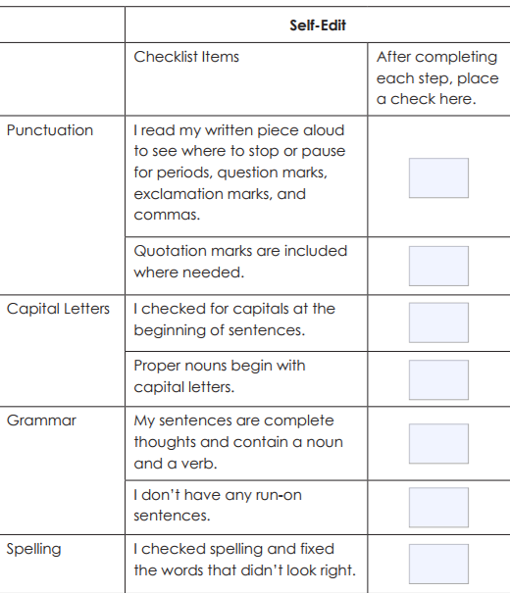

Retrieved from http://www.readwritethink.org/files/resources/printouts/Editing%20Checklist.pdf

